**Network Topology**

## Kali-Linux

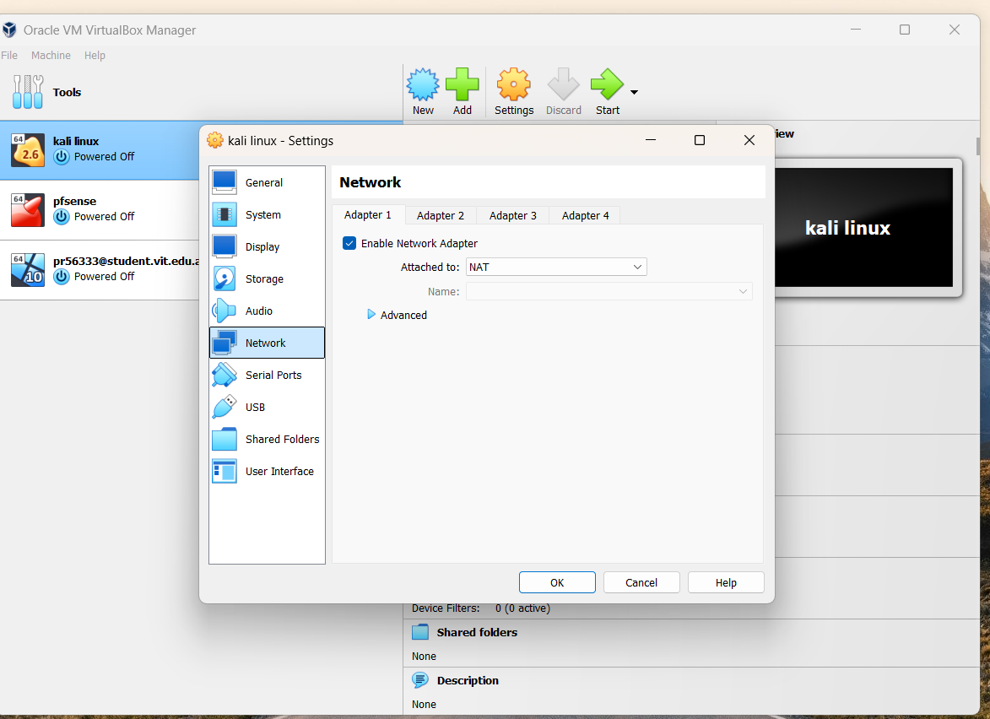

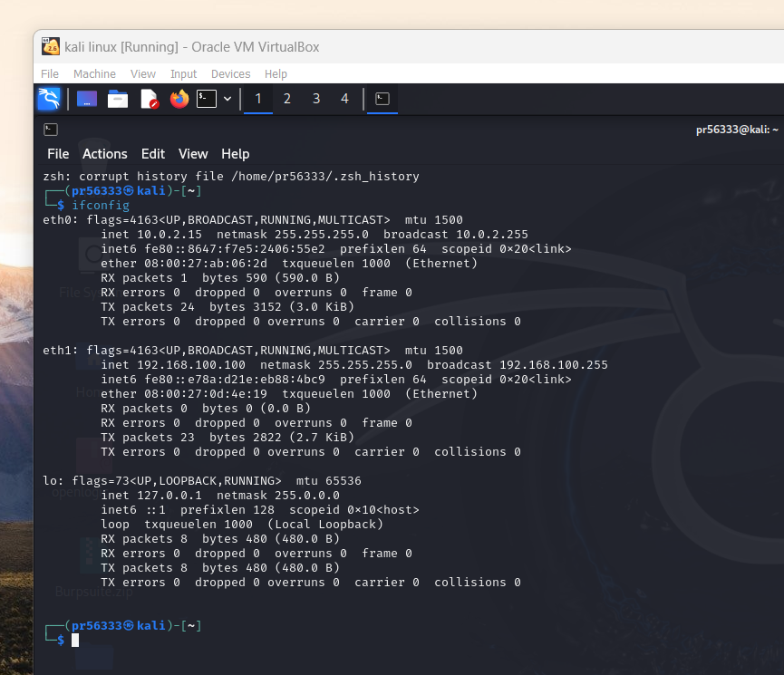

## Windows

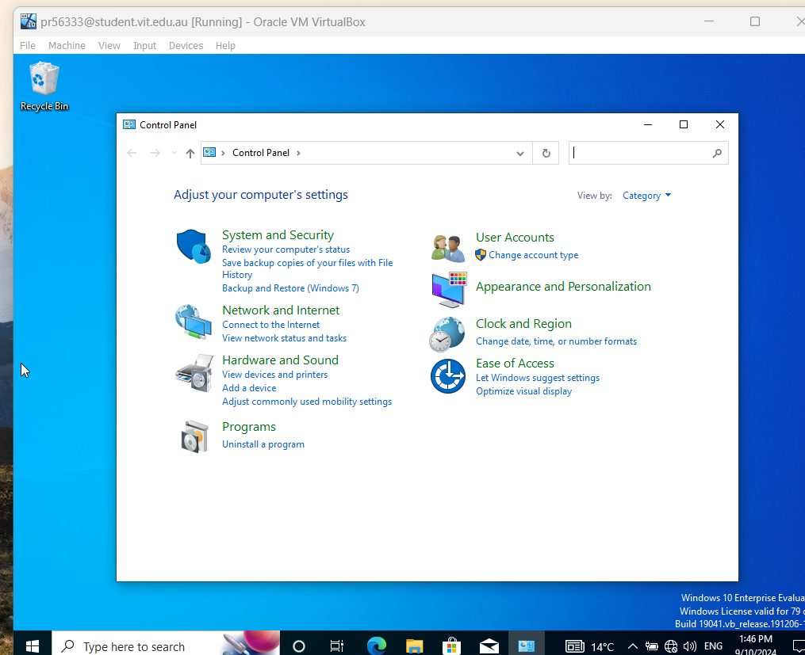

## Pfsense



